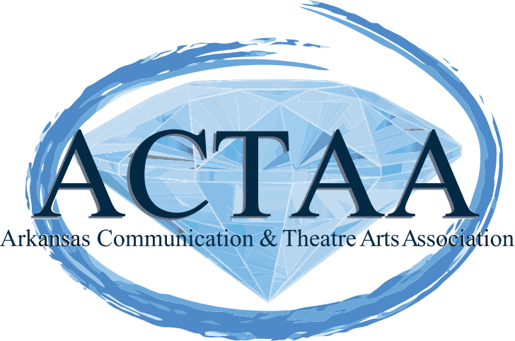

|  |  |
| --- | --- |
| **President's gavel is passed to our new President!**   |  | | --- | | Helen L. Strickland accepted the President's gavel from President Dawn Tucker on Sunday, April 13, 2014 at the close of the Arkansas Communication and Theatre Arts Association Executive Council meeting.  http://www.actaa.net/resources/EmailTemplates/ACTAA%20President/images/helen%20photo.JPG  President Strickland teaches Drama at Hall High School in the Little Rock School District.  She also works in three additional roles at Hall High School that include the Director of Forensics and Debate, Head Forensics Coach, and the Troupe Director of the International Thespian Society Troupe #7862 (a drama honor society).  In Helen’s own words:  "ACTAA:  The Core of Education" was our theme for Fall Conference 2013.  In my heart, soul, and mind; I really believe that we set a firm foundation for the educators, teachers, and students that we serve in ACTAA.  Knowing how to express one's self really is the core of education and we as educators in ACTAA really do prepare students for their future in terms of communicating effectively with others whether it's through dance, drama, debate, and the other core areas that we teach.  During my term as President of ACTAA, I want to serve you all as effectively as possible.  Please feel free to communicate with me anytime and I will listen to your concerns.  I will also do what I can along with the executive council and membership to accomplish "our goals".   We really need all of us to do our part in order for ACTAA to continue to thrive as it has been a viable organization for the past 74 years.   It is only through educators volunteering their time and working hard that ACTAA will continue to survive.  We need all of you; so please get on board and "from your core" keep our organization strong and increase our membership growth through your own vital participation.  ACTAA Executive Director, Mary M. Richardson, Hendrix College stated that  "It is very important to ACTAA and Arkansas that Helen is serving as the first African-American President of the Arkansas Communication and Theatre Arts Association in 75 years.  But as important as that milestone is, she is the right person for this job in our 75th year as an organization.  She is always so positive and works toward inclusiveness for everyone.  She cares about ACTAA and where we are headed.  As 1st Vice President, she worked tirelessly on preparing for our fall conference 2013.  In preparation for becoming President, she contacted and filled our committee membership by touching base personally with our members in one weekend.  She knows our constitution better than I do!  These comments are not only about the importance of race and gender in our organization but are also about a good person who is ready to lead at the right time in the right place.  I am so excited for ACTAA right now and where we are headed. We have had excellent leaders for the past 74 years and this year will be no different.  Helen L. Strickland will lead ACTAA into the future! | |

|  |
| --- |
|  |

|  |  |  |  |
| --- | --- | --- | --- |
| |  |  |  | | --- | --- | --- | | |  |  | | --- | --- | |  |  | | |